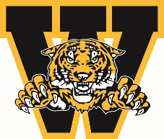
WELLAND MINOR HOCKEY ASSOCIATION
ANNUAL GENERAL MEETING AWARDS

WELLAND MINOR HOCKEY COACH OF THE YEAR AWARD

Awarded to the head coach who reflects the coaching standards of WMHA, which includes showing respect to officials, opponents and parents, promoting a philosophy of fair play, demonstrating concern for the development of the athlete, responsible conduct beyond the athletic arena, and presenting a positive public image of coaching in the role of the head coach.

You must be a member in good standing to nominate a person you feel is deserving of this award. Please complete the form below and submit to Welland Minor Hockey President by emailing president@wellandminorhockey.com

Nominee’s Name:

Team Associated with:

Nominated by:

Contact #

Why are you nominating this individual? Please give us a brief description and/or overview of why they are deserving.

Signature: ___________________________________________ Date: ___________________________

