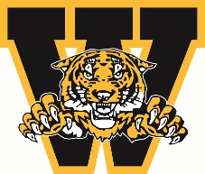
WELLAND MINOR HOCKEY ASSOCIATION
ANNUAL GENERAL MEETING AWARDS

HOUSE LEAGUE/LOCAL LEAGUE COACHING STAFF AWARD

Awarded to the coaching staff in HL/LL who exceeded expectations, going beyond and above to ensure all players had an excellent year. Presented to individuals who show leadership, demonstrates skills development and have sound philosophy. Team success is a factor, but the attributes and characteristics of these individuals goes well beyond winning.

You must be a member in good standing to nominate a person you feel is deserving of this award. Please complete the form below and submit to Welland Minor Hockey President by emailing president@wellandminorhockey.com

Nominee’s Name:

Team Associated with:

Nominated by:

Contact #

Why are you nominating this individual? Please give us a brief description and/or overview of why they are deserving.

Signature: ___________________________________________ Date: ___________________________

