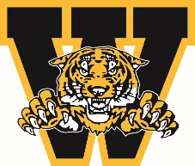
WELLAND MINOR HOCKEY ASSOCIATION
ANNUAL GENERAL MEETING AWARDS
April 2024

OUTSTANDING SERVICE AWARD – EXECUTIVE AWARD

Awarded to an executive member who has gone above and beyond, hard-working, dedicated leadership at the executive level.

You must be a member in good standing to nominate a person you feel is deserving of this award. Please complete the form below and submit to Linda Falovo-Atkinson by emailing linda67atkinson@gmail.com

Nominee’s Name:

Team Associated with:

Nominated by:

Contact #

Why are you nominating this individual? Please give us a brief description and/or overview of why they are deserving.

Signature: ___________________________________________ Date: ___________________________

Deadline for submission March 15, 2024

