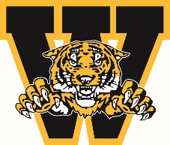
WELLAND MINOR HOCKEY ASSOCIATION
ANNUAL GENERAL MEETING AWARDS
April 2024

ERNIE CLAYTON MEMORIAL AWARD

This award is presented on an annual basis to a House League/Local League Team Manager who throughout the year has provided committed, reliable and efficient service to their team. The time and energy they dedicate towards making the hockey season a positive experience for everyone around them does not go unnoticed.

You must be a member in good standing to nominate a person you feel is deserving of this award. Please complete the form below and submit to Linda Falovo-Atkinson by emailing linda67atkinson@gmail.com

Nominee’s Name:

Team Associated with:

Nominated by:

Contact #

Why are you nominating this individual? Please give us a brief description and/or overview of why they are deserving.

Signature: ___________________________________________ Date: ___________________________
Deadline for submission March 15, 2024

